RFID based Smart Electronic Voting Machine

Anjali Tiwari¹, Ankit Yadav², Omkar Singh³, Mrs. Anshu Khare⁴
^{1,2,3}(Student, Department of Electronics and Communication Engineering, School of Management Sciences, Lucknow, Uttar Pradesh), ⁴(Asst. Professor, Department of Electronics and Communication Engineering, School of Management Sciences, Lucknow, Uttar Pradesh)

Abstract: This study describes the smart electronic voting machine using RFID. As the elections provides a strong influence on the people and made the prominent feature of the country, in India where anyone can cast their vote according to their requirements. This project proposes a good idea of making a smart voting machine that is very good for election process comparing that of from traditional voting machine where ballot papers are used. This project has RFID sensor that is very effective to provide the security to the election process as by the use of RFID no one can misuse it and only the authorized person is able to see the results by using the RFID reader or card.

Key word: RFID, Arduino UNO, LCD screen, Buttons.

I. INTRODUCTION
The EVMs were commissioned in 1989 by Election Commission of India in collaboration with Electronics Corporation of India Limited. The EVMs were first used in 1982 in the by- election to North Paravur Assembly Constituency in Kerala for a limited number of polling stations. EVMs reduce the time in casting a vote and declaring the results.
In recent years, the introduction of electronic voting machines (EVMs) has revolutionized the landscape of electoral systems across the globe. With the advent of digital technology, traditional paper-based voting methods have gradually given way to

more efficient and sophisticated electronic alternatives. EVMs represent a significant advancement in the realm of democracy, aiming to streamline the voting process, enhance accuracy, and bolster the integrity of elections. By replacing cumbersome paper ballots with intuitive touch screen interfaces or keypad inputs, EVMs offer voters a user-friendly experience while facilitating swift and precise tabulation of votes.

II. OBJECTIVE
The main objective of our project is to design and make a smart electronic voting machine that reduces the time usage on traditional voting machine and provides a easiness in casting a vote and provide the results in no time. This project helps others to cast their vote according to their needs.

III. WORKING PRINCIPLE
EVM operate on a simple principle of digital recording and tabulation. When a voter presses a button or touches a screen to cast their vote, the machine records their choice digitally. At the end of the voting period, the EVM tallies up all the counts of the votes and produces the final count. This system aims to provide a faster, more accurate and efficient way of conducting elections compared to traditional paper methods. The working principle of electronic voting involves several key steps:

- Voter authentication
- Ballot selection
- Vote recording
- Verification
- Vote tallying
- Prevention of duplicate voting
- Secure transmission
- Anonymity
- Audit ability and transparency
- Accessibility features
- Compliance and certification

1. Voter Authentication: Each eligible voter is issued a unique RFID card or tag, containing their voter information and a unique identifier. Before voting, the voter presents this RFID card to the EVM. RFID Reader: The EVM is equipped with an RFID reader, which reads the information stored on the RFID card when the voter presents it.

2. Verification: The EVM verifies the authenticity and eligibility of the voter based on the information read from the RFID card. This verification process typically involves checking the voter's registration status, identity, and any other relevant criteria defined by election authorities.

3. Prevention of Duplicate Voting: RFID technology helps prevent duplicate voting by ensuring that each RFID card can only be used once. Once a card is used to cast a vote, it cannot be used again in the same election.

4. Secure Transmission: After the voter is authenticated, they interact with the EVM's interface to cast their vote electronically. The vote data is securely transmitted and stored within the EVM's internal memory or a secure external server.

5. Anonymity: The EVM ensures the secrecy of the ballot by not associating the RFID tag information with the actual vote cast. This ensures that each vote remains anonymous and cannot be traced back to the individual voter.

6. Audit ability and Transparency: EVMs using RFID technology often include features for auditing and verifying the integrity of the voting process [5]. This may include the ability to generate paper audit trails or cryptographic methods for ensuring the accuracy of the vote count.

7. Security Measures: EVMs employ various security measures to protect against tampering, unauthorized access, and manipulation of vote data. These measures may include encryption, tamper-evident seals, physical security protocols, and strict access controls.

8. Accessibility Features: EVMs using RFID technology may incorporate accessibility features to accommodate voters with disabilities, such as audio instructions, tactile interfaces, or alternative methods for presenting RFID cards. 9. Compliance and Certification: EVMs using RFID technology must adhere to strict standards and regulations set forth by election authorities to ensure fairness, transparency, and accuracy in the voting process. They often undergo rigorous testing, certification, and auditing processes before being deployed in elections.
By integrating RFID technology into electronic voting machines, election authorities aim to enhance the efficiency, security, and trustworthiness of the voting process while ensuring the integrity and secrecy of each vote cast.

IV. BLOCK DIAGRAM

The block diagram consists of RFID tag in which RFID card or reader, DC power supply, buzzer, Arduino UNO, polling switching.

1. RFID- Radio-frequency identification (RFID) uses electromagnetic fields to automatically identify and track tags attached to objects. An RFID system consists of a tiny radio transponder called a tag, a radio receiver, and a transmitter. When triggered by an electromagnetic interrogation pulse from a nearby RFID reader device, the tag transmits digital data, usually an identifying inventory number, back to the reader. This number can be used to track inventory goods. Passive tags are powered by energy from the RFID reader's interrogating radio waves. Active tags are powered by a battery and thus can be read at a greater range from the RFID reader, up to hundreds of meters.

2. ARDUINO- The Arduino Uno is an open-source microcontroller board based on the Microchip ATmega328P microcontroller (MCU) and developed by Arduino.cc and initially released in 2010. The microcontroller board is equipped with sets of digital and analog input/output (I/O) pins that may be interfaced to various expansion boards (shields) and other circuits. The board has 14 digital I/O pins (six capable of PWM output), 6 analog I/O pins, and is programmable with the Arduino IDE (Integrated Development Environment) [7], via a type B USB cable. It can be powered by a USB cable or a barrel connector that accepts voltages between 7 and 20 volts, such as a rectangular 9-volt battery.

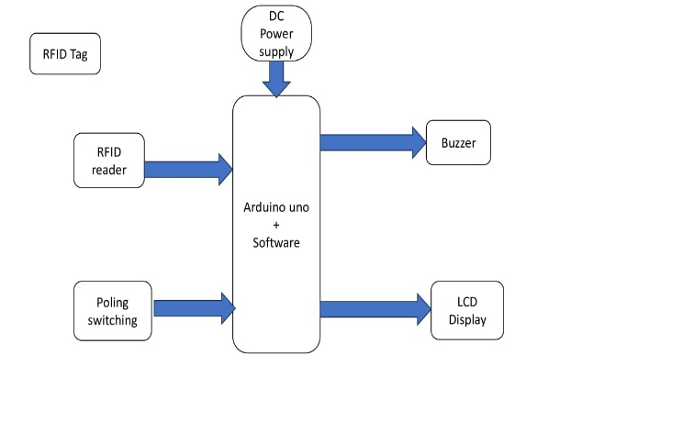

3. LCD DISPLAY- A LCD display is a type of alphanumeric liquid crystal display (LCD) module that is commonly used in electronic devices such as digital clocks, calculators, and small embedded systems. The refers to the number of characters and lines that the display can show at once - 16 characters can be displayed on each of the 2 lines. The LCD display typically consists of a backlight, a controller chip [9], and a row of pins for connecting to a microcontroller or other electronic device. The display uses a parallel interface to communicate with the controlling device, with each character or command sent as a series of data and control signals.

V. CIRCUIT DIGARAM
Figure shows the circuit diagram of smart electronic voting machine. It shows the overall connection of all the components with each other and how they are performing their functions individually.

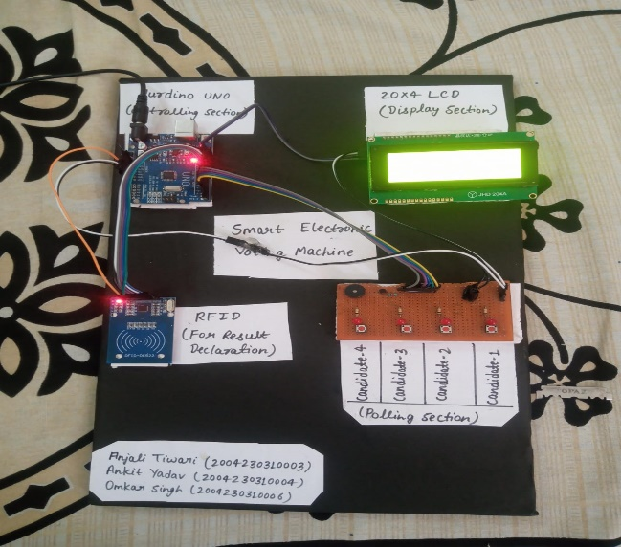

VI. CONCLUSIONS
This project provides others to allow them to vote independently, the implementation of smart electronic voting machines leveraging RFID technology presents a promising avenue for modernizing electoral processes. Throughout this study, we have explored the numerous advantages that RFID-based systems offer, including enhanced efficiency, accuracy, and accessibility for voters of all backgrounds. By utilizing RFID tags embedded in voter cards or other identification mediums, the process of authentication and ballot casting can be streamlined, reducing waiting times and improving overall voter experience.

VII. REFERENCES

[1]. Z.Enyedi. The influence of voting advice applications on preferences, loyalties and turnout
[2]. Dr.Alok Shukla. The true story of electronic voting machine.
[3]. D.Krishna, electronic voting machine and providing authentication
[4]. Deepika Iswarya, Rathna Prabha and Trini Xavier, A survey on E-voting system using Arduino software
[5]. Ashok Kumar D., Ummal Sariba Begun T., A novel design of electronic voting system
[6]. E.G.Carmines and J.A.Stimson. The two faces of issue voting
[7]. Andreadis. Voting advice applications: a successful nexus between informatics and political science.
[8]. Benjamin B., Bederson, Bongshin Lee, Robert M. Sherman, Paul S, Herrnson, Richard G. Niemi, Electronic Voting System usability issues.
[9]. S.Borzsony, D. Kossmann and K. Stocker The sykyline operator.
[10]. P.C.Fishburn. Utility theory for decision making

